Assignment 32.2

Problem Statement:

● Use Hbase shell for performing the following operations

● Create the table customer with two column families

● Personal details and order details as column families. Create a unique number as row key (ssn/Aadhar no.,etc) Insert at least 10 records to each column Insert following values for personal details column family Name, age, city, state

● Insert following values for order details column family

● Order no., order quantity, and order amount

● Use put command to insert the values for each record. Use get command, to retrieve all the records of single customer.

Creating table customer with two column families personal and order.

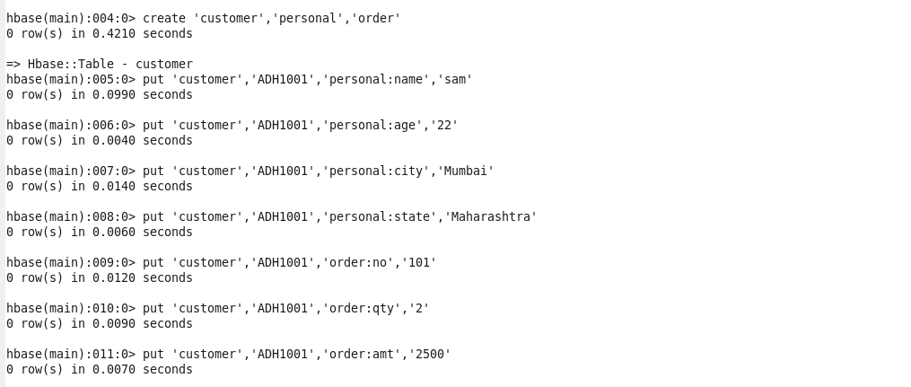

Put command used to insert details of record.

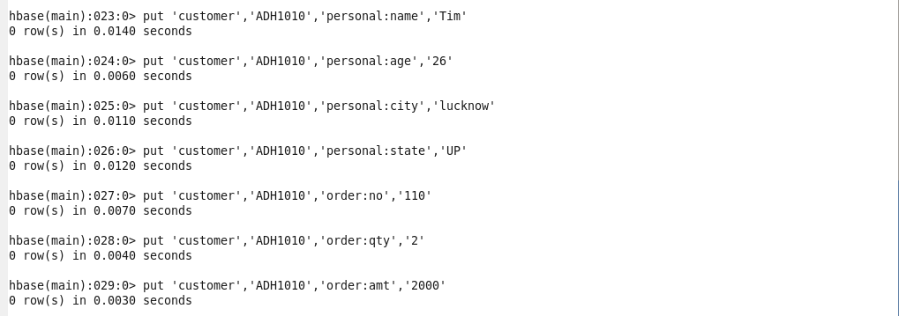

Get command used to retrieve details of record with row key ADH1008.

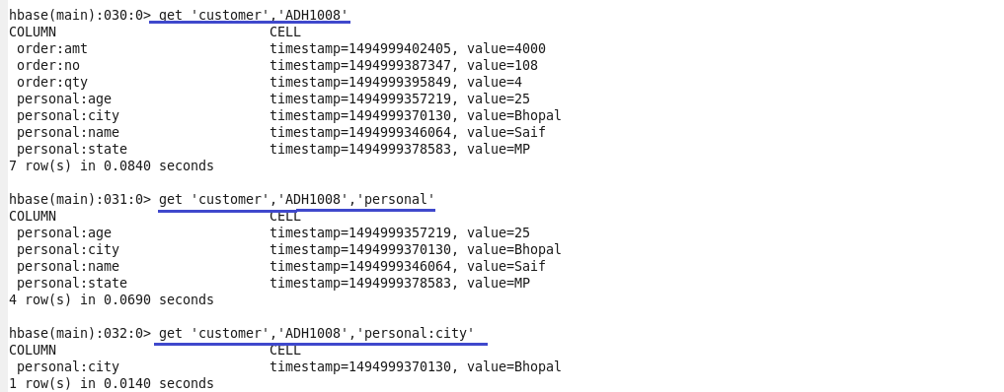

Scan command used to display details of all 10 records.

